Lab # 05

Unity API (Input System, Collision and Trigger Methods)



Fall 2024

**CSE-411L Intro to Game Development Lab**

Submitted by: MUHAMMAD SADEEQ

Registration No.: 21PWCSE2028

Section: C

“On my honor, as a student of the University of Engineering and Technology, I have neither given nor received unauthorized assistance on this academic work”

Submitted to:

Engr. Abdullah Hamid

(1 Nov 2024)

Department of Computer systems engineering

University of Engineering and Technology, Peshawar

1. I created a player cube that moves forward, backward, left, and right.

**Player Script Code:**

using System.Collections;

using System.Collections.Generic;

using UnityEditor;

using UnityEngine;

public class Movement : MonoBehaviour

{

[SerializeField]

private float speed = 1f;

// Update is called once per frame

void Update()

{

if (Input.GetKey(KeyCode.W))

{

transform.Translate(Vector3.forward * speed * Time.deltaTime);

}

if (Input.GetKey(KeyCode.S))

{

transform.Translate(Vector3.back * speed * Time.deltaTime);

}

if (Input.GetKey(KeyCode.A))

{

transform.Translate(Vector3.left * speed * Time.deltaTime);

}

if (Input.GetKey(KeyCode.D))

{

transform.Translate(Vector3.right * speed * Time.deltaTime);

}

}

private void OnCollisionEnter(Collision collision)

{

if (collision.gameObject.CompareTag("Ball"))

{

collision.gameObject.GetComponent<MeshRenderer>().material.color = Color.yellow;

}

}

private void OnCollisionExit(Collision collision)

{

if (collision.gameObject.CompareTag("Ball"))

{

collision.gameObject.GetComponent<MeshRenderer>().material.color = Color.white;

}

}

}

1. I changed the Main Camera’s Transform values to set the Camera top-down view.
2. I created maze from different sizes of cubes on the plane

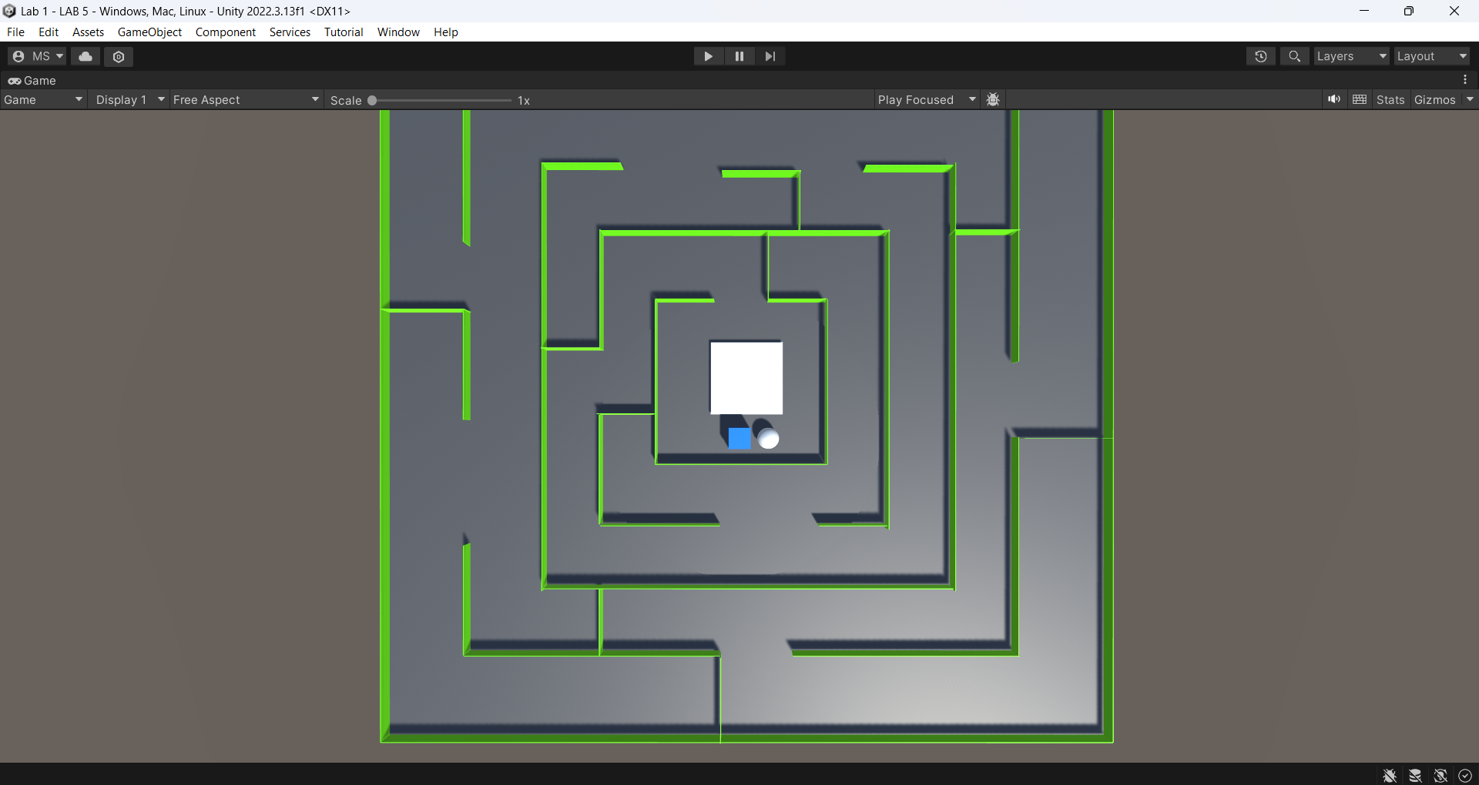

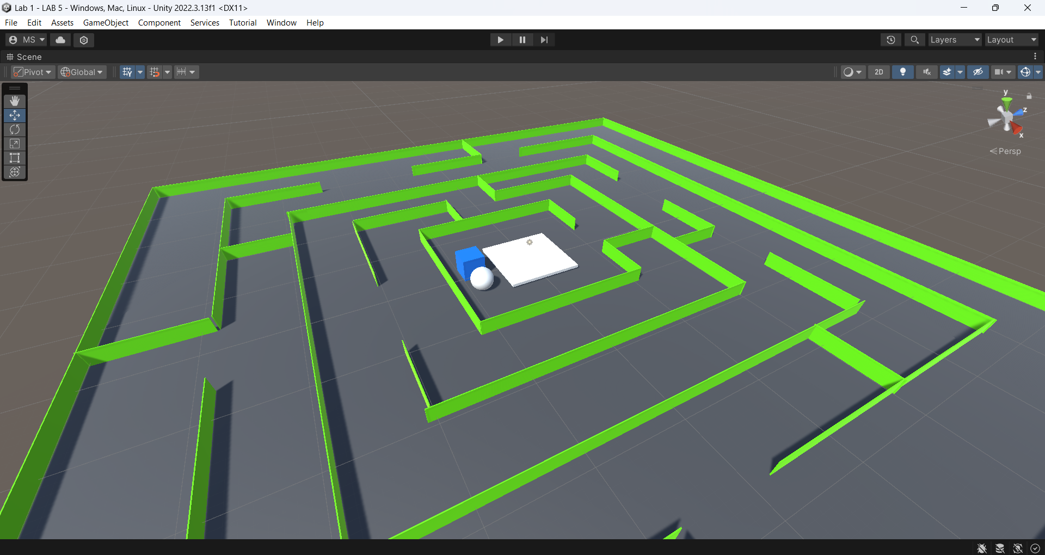

1. I added below script to Goal gameobject in the inspector

**Goal Script Code:**

using System.Collections;

using System.Collections.Generic;

using UnityEngine;

public class Goal : MonoBehaviour

{

private void OnTriggerEnter(Collider other)

{

if (other.gameObject.CompareTag("Ball"))

{

gameObject.GetComponent<MeshRenderer>().material.color = Color.green;

}

}

private void OnTriggerExit(Collider other)

{

if (other.gameObject.CompareTag("Ball"))

{

gameObject.GetComponent<MeshRenderer>().material.color = Color.white;

}

}

}

1. I added below script to Ball gameobject in the inspector

**Ball Script Code:**

using System.Collections;

using System.Collections.Generic;

using UnityEngine;

public class Ball : MonoBehaviour

{

[SerializeField]

private Material Green;

private void OnCollisionEnter(Collision collision)

{

if (collision.gameObject.CompareTag("Wall"))

{

collision.gameObject.GetComponent<MeshRenderer>().material.color = Color.red;

}

}

private void OnCollisionExit(Collision collision)

{

if (collision.gameObject.CompareTag("Wall"))

{

collision.gameObject.GetComponent<MeshRenderer>().material.color = Green.color;

}

}

}

1. Also in the Movement script I made logic if the player touches the ball it will turn yellow and if it do not touch it will get its original color back

